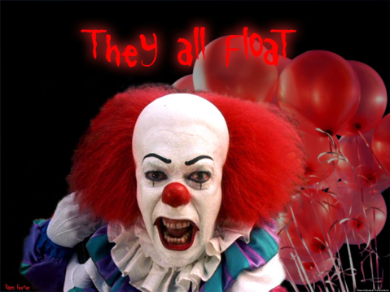
Horror Fiction Unit Notes Name: _________________________
What is horror fiction?
- _____________ _____________ is fiction in any medium intended to scare, unsettle, or horrify the audience.
- Historically, the cause of the “horror” experience has often been the intrusion of an ________ or ____________________ supernatural entity into everyday human experience.
- Since the 1960’s, any work of fiction with a ___________, ____________, _____________ or ________________ theme has come to be called “horror.”
- Horror often overlaps with ____________ ___________ and __________ and falls into the classification of supernatural fiction.

Origin and History of Horror
- Many of today’s horror ________________ can be found in tales and folklore of ancient cultures.
- Modern horror fiction found its roots in gothic novels such as Mary Shelley’s Frankenstein (1818) and Bram Stoker’s Dracula (1897).
- The first published American horror story was Washington Irving’s short story, _____________________________________________
- Other early American horror writers include _________ _________ ______ and ____ ______________, both best known for their short stories.

Contemporary Horror
- Early horror works used ___________ and ___________ to deliver an eerie and otherworldly flavor, but usually avoided the explicit violence.
- Some modern horror writers use vivid depictions of extreme violence or shock to entertain, but many contemporary writers such as ___________ ____________ and ______________ __________ can usually pull off the horror effect without such extreme violence.
- Despite the often graphic or adult subject matter of horror stories and films, authors such as King have noted that horror as a genre is actually concerned with re-establishing normalcy and morality. Some ways that this can be seen include: ___________________________________ _______________________________________________________________________________________________________________________________________________________________________________________________________________________________________.
- Horror fiction is now not just confined to paper though. Countless horror films have been released in the 20th century, such as _____________, ______________, ___________________ _____________, __________________________, __________, etc.

Horror Archetypes
- An _____________ is a model of a character or something else that recurs throughout literature.
- In Stephen King’s guide to horror fiction, The Danse Macabre, he cites that there are four major horror archetypes: _______________, ________________, __________________, and ________________________________________________.
- However, there are many more archetypes such as: ___________, ____________, _____________, _________________, ______________, ______________, _______________, etc.

Elements of Horror
- ___________________________—Fear that imposes itself on and causes unnatural effects on the mind. (The thing that makes you shudder)
Example from Clip:

- ___________________________—Fear that one’s body or life is actually in danger.
Example from Clip:

- ___________________________—Anything characterized by ludicrous or freakish distortion of appearance or manner.
Example from Clip:

- _______________________—Anxiety or apprehension resulting from an uncertain, undecided, or mysterious situation.
Example from Clip:

- _______________________—A secondhand story told as truth about some horrific series of events that “supposedly” happened to a real person.
Example from Clip:

- _______________________ --A funny character or scene in a serious work, designed to relieve tension in the audience momentarily
Example from Clip:

- _______________________—When the opposite of what you expect happens
- _______________________—Occurs when the audience knows something that the characters do not.
- _______________________—When someone says something but means the opposite.
- _______________________—Presenting an indication or suggestion beforehand of things to come.

