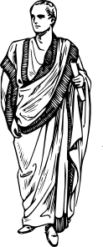
LEARNING STATION #1: The History of Greek Drama & GREEK ACTORS

***Directions: Using the information provided, write your answers on your note sheet.

The History of Greek Drama
The earliest origins of drama are to be found in Athens, the capital of Greece. The Dionysia was an annual festival of dances and songs performed in honor of the god Dionysus (the god of wine and procreation). Soon, the song-like storytelling evolved into an enactment of Dionysian legends in Greek history.
The first plays were performed with just one actor and a chorus of people who helped him to tell the story. Eventually, certain members of the chorus (those who sung the songs) evolved to take special roles within the procession, but they were not yet actors in the way we would understand it.
Eventually the ruler of the city established a series of competitions in music, singing, dance and poetry. And most remarkable of all the winners was said to be a man named Thespis. According to tradition, in 534 or 535 BC, Thespis astounded audiences by leaping on to the back of a wooden cart and reciting poetry as if he was the characters whose lines he was reading. In doing so he became the world's first actor thus acting was born.
Soon, theatres proved to be so popular they spread all over Greece. The Ancient Greeks took their entertainment very seriously and used drama as a way of investigating the world they lived in, and what it meant to be human.
GREEK ACTORS
Participating in Greek drama was considered to be a citizen’s public duty. Citizens were expected to perform in the chorus. Experienced performers trained in the art of public speaking were promoted to the status of an actor. The Greek actor was highly regarded in Greek society and was often exempt from military duty. Since Greek society was male-dominated, women were not allowed to act.
Since an actor needed to be seen by the audience, he wore long, flowing robe with a great deal of padding and high, plat-formed shoes. Although he gained in size, he wasn’t able to move around much. Limited mobility forced the actors to develop broad, sweeping gestures to signify emotions such as the beating the breast and tearing their clothes to indicate mourning and grief. The long distance between the actors and the audience also forced them to use dramatic speech.

The History of Greek Drama Name:

The Origins of Greek Drama

- Where can the origins of drama be found?

- What is a “Dionysia” and why is this a significant event?

- What did the song-like storytelling evolve into?

- How were the first plays performed?

- How did “acting” eventually come about?

- Why was drama important to the Greeks?

Greek Actors

- What was considered a citizen’s public duty?

- How did one become an actor?

- What were the privileges of an actor?

- Why were women prohibited from acting?

- How did actors dress to ensure that they were seen?

- How did their attire limit them on stage?

- How did the actors remedy this limitation?

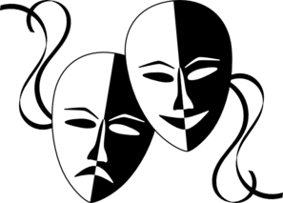
LEARNING STATION #2 – The Mask and Structure of Greek Theatre
Directions:
***Using the information provided, write your answers on your note sheet and label your Greek theatre diagram appropriately.

The Greek Mask
To take on the role of a specific character, Greek actors often wore masks. The mask also served as a megaphone with a large opening for the mouth. It identified age, sex, mood, and rank. Fully hooded, it rested on the shoulders of the actor. The flexibility of changing masks allowed actors to change roles easily.
Parts of Greek Theatre
Skene: Directly behind the Orchestra, it was a building used as an area into which actors could exit the scene to change costumes and masks.
Proscenium: Acting area, or stage, in front of the skene.
Orchestra: Ground-level area where the chorus performed. It was in front of the proscenium.
Parados: Passage on the left or right through which the chorus entered the orchestra.
Theatron: Tiered seating area built into a hillside in the shape of a horseshoe
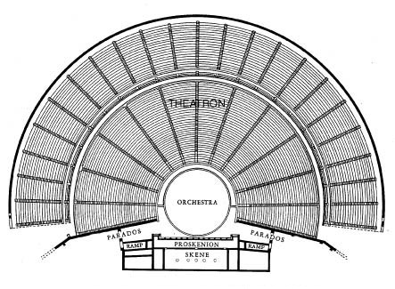
Structure of Greek Theatre

Greek Masks
- Give the four functions of the Greek masks:
a. c.

b. d.
Greek Theater: Give the definitions for each label:
Skene:

Proscenium:

Orchestra:

Parados:

Theatron:

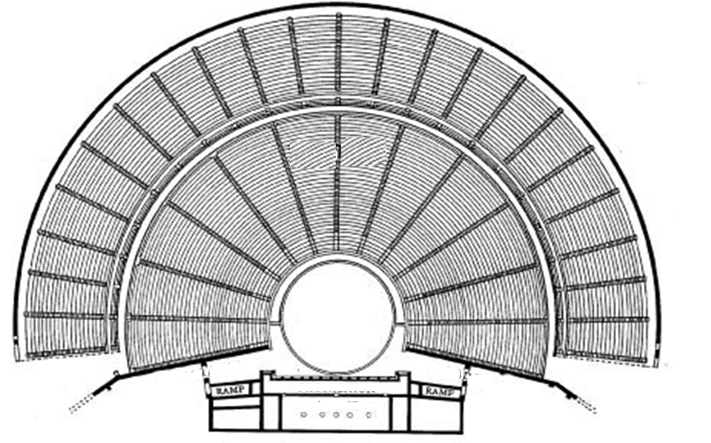Label the Greek Theater with the labels above.

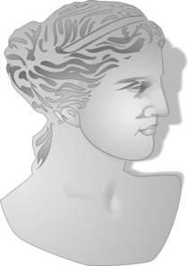
LEARNING STATION # 3 – PRE-READING QUESTIONS & ANTICIPATION GUIDE
***Directions: Answer all questions on your own paper. You do not have to write the questions.
- If you defied your parents and did something wrong, what’s the worst punishment they could dole out to make sure you wouldn’t do such a thing again?
- Should a person be judged guilty of a crime if he or she is unaware that any crime was being committed?
- Is being self-assured ever a bad thing?
- Have you ever wanted to see a movie after having read the book? Why would you want to spend the money if you already know the story?
ANTICIPATION GUIDE
“Oedipus the King”
- Agree or Disagree? Read the following statements, then on the line provided to the left of each theme, write an “A” if you agree, or a “D” if you disagree.
- Explain why you agree or disagree using complete sentences for each.
- Do not write these. Only give answers!

Agree OR Disagree
_____ 1. It is possible to escape or trick fate.

______2. If we truly know ourselves, we can prevent careless mistakes.

______3. We should not attempt to justify our actions, good or bad.

_____ 4. Family secrets are best kept as just that--secrets.

_____5. If you are in charge, you are allowed to be exempt from consequences.

_____ 6. We should engage ourselves in bettering our community, even if it is our self that we must change.

_____7. Society should place the consequences of the parent’s sins on the heads of the children.

_____8. There is more than one way to see.

_____9. It is better to place blame on those around us than to look inside ourselves.

_____10. There are no coincidences.

_____11. All types of pride are evil.

LEARNING STATION #4 – Video Segment of Greek Drama Performance

Written almost 2,500 years ago, you are about to view a segment of the Greek tragedy, “Oedipus Rex.” As you watch this segment, pay close attention to how the actors move and speak. Are there any props in the background?

Write a one page response in which you compare and contrast ancient Greek drama with modern dramatic forms such as movies and modern theatre.

LEARNING STATION #5- The Greeks and Religion
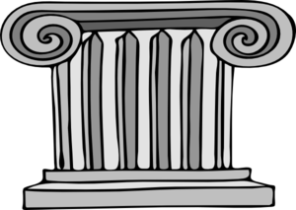
***Directions: Using the information provided, write the questions and answers on your own paper.
Ancient Greece was one of the world’s greatest civilizations. The Greeks made many important and lasting contributions to humanity--including the idea of democracy and the art of drama. They were also the first people to study medicine, physics, and philosophy. But the ancient Greeks also placed a high value on physical fitness. They loved sports thus invented Olympic Games, which are still popular today.
Religion was a very important aspect of Greek society and culture. It was polytheistic, consisting of the worship of many Gods. The Greeks believed that the Gods would offer protection and guide their communities. The Greeks placed much emphasis on pleasing the Gods in order to live a life free of oppression and hardship. The Greeks believed that they had to worship and please the Gods in order to have good fortune. The Greeks participated in a number of rituals, rites, ceremonies and sacrifices in order to impress and placate the Gods. Temples, shrines and statues were erected as a designated place to offer sacrifices to the Gods.
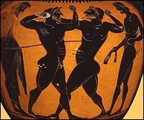
The Gods were admired and feared, being distinguished from man by their immortality. The Greeks believed that the Gods controlled natural and social forces and resided on Mount Olympus. The Greeks were an earth based culture, holding a high respect for nature and the earth. To reflect this love of nature, the Greeks placed different Gods in charge of different aspects of life. The Greeks used the Gods to explain the occurrence of things, which they could not understand through lack of scientific proof. For example they thought that the Gods controlled the rising and setting of the sun and created great myths about such events.
The Greeks worshipped twelve main Gods including Hades; God of the underworld, Aphrodite; Goddess of love, Apollo; God of light, and Zeus; King of Gods, thunder and lightning.
- List two important contributions the Greeks gave to humanity.
- What is one event the Greeks created that still takes place today?
- The Greeks were the first people to study what three things?
- What were the two main purposes of the Greek gods?
- How did the Greeks impress and please the gods?
- Name two characteristics of the Greek gods.
- How many gods did the Greeks worshipped and where did they reside?
- Name three of the twelve gods.
- In your opinion, what did the Greeks believe would happen if a person mocked and disobeyed the gods?

Learning Station #6: The Elements of the Greek Tragedy

Use the iPads and Powerpoint to answer the following questions.

What are the three principles of a Greek Tragedy?

Define:
Tragic Hero

Hubris

Catastrophe

Peripeteia

Anagnorisis

Fate

Nemesis

Hamartia

Short response: Identify the following elements of the Greek Tragedy in The Odyssey, using Odysseus as your tragic hero.

Catastrophe

Peripeteia

Anagnorisis

Fate

Nemesis

Hamartia

